Week 1-0

Coding -C-Language Features -Optional ROLL NO: 241801324
Name: Yogadharshini N K

Q1)Given below is a simple program written in C language

Change the text in the code given below to make the program print “Hello C” instead of “Hello B”.

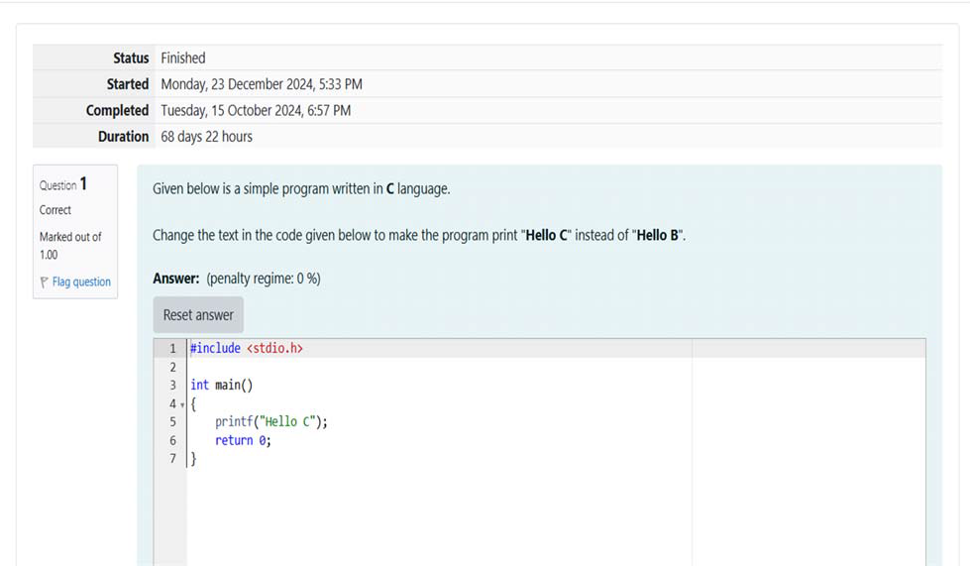

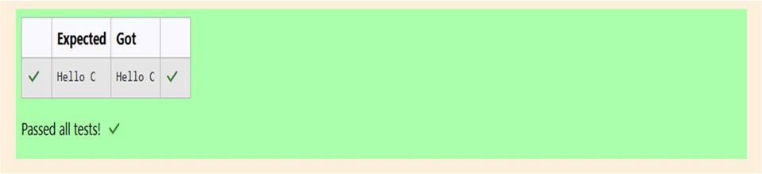

Q2) The code given below contains instructions to print the text “I love Apples” to the console
The \n in the text “I love Apples\n” ensure that the breaks after printing the text “I love Apples” (Which means that nothing else in printed on the same line ).
Follow the steps given below to change the text execute compile command and ﬁnally execute the ﬁle:
1. In the code given below, change the text to print “I love Apples”.

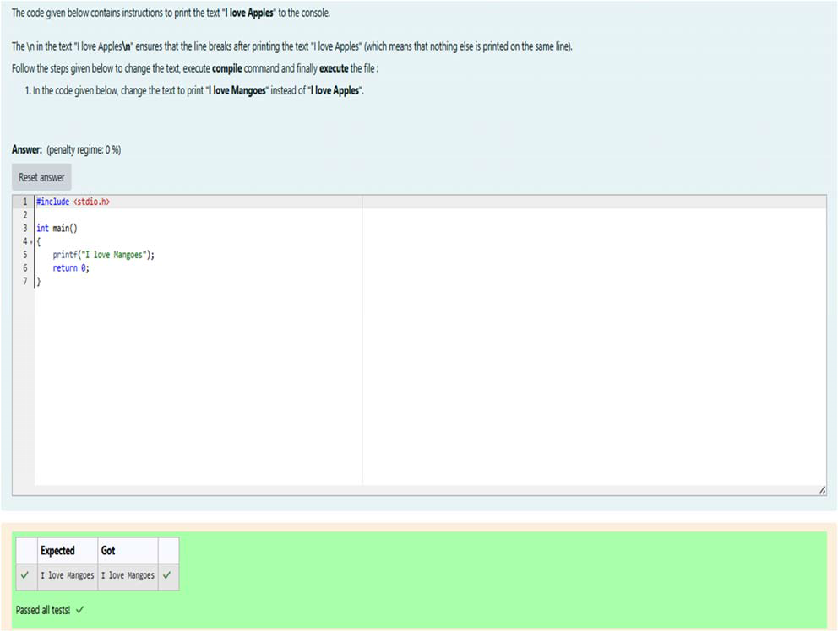

Week 1-01:
Practice Session-Coding. ROLL NO: 241801324
Name: Yogadharshini N K

Q1) This is a simple challenge to help you practice printing to stdout. We’re starting out by printing the most famous computing phrase of all time! In the editor below, use either printf or cout to print the string Hello, World! To stdout. Input Format You do not need to read any input in this challenge. Output Format Print Hello, World! to stdout.Sample Output 1 Hello, World! Answer:(penality regime: 0%)

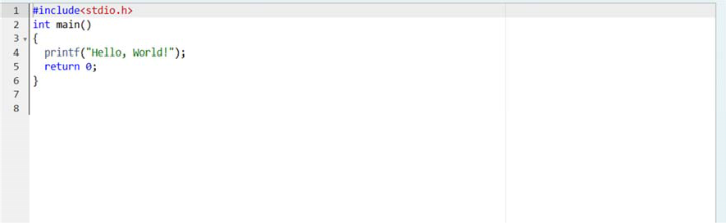
OUTPUT:

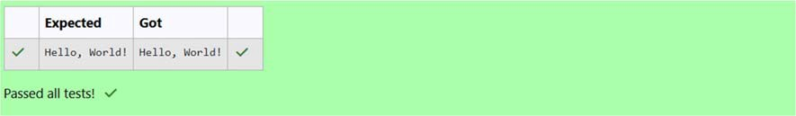

Q2) ) Objective This challenge will help you to learn how to take a character, a string and a sentence as input in C. To take a single character ch as input, you can use scanf(“%c”, &ch); and printf(“%c”, ch) writes a character speciﬁed by the argument char to stdout: char ch; scanf(“%c”, &ch); printf(“%c”, ch); This piece of code prints the character ch. Task You have to print the character , ch. Input Format Take a character, ch as input. Output Format Print the character, ch. Answer: (penalty regime: 0 %)

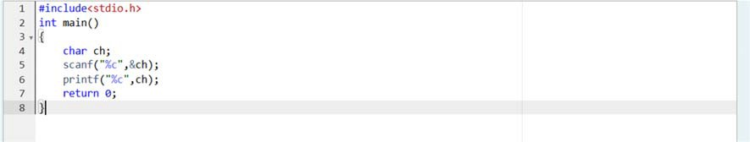

OUTPUT:

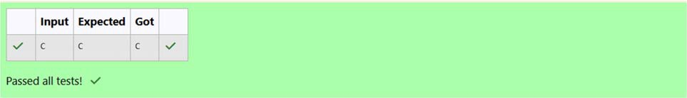

Q3) Objective The fundamental data types in C are int, ﬂoat and char. Today, we’re discussing int and ﬂoat data types. The print() function prints the given statement to the console. The syntax is printf (“format string”, argument_list);. In the function, if we are using an integer, character, string or ﬂoat as argument, then in the format string we have to write %d (integer), %c (character), %s (string), %f (ﬂoat) respectively. The scanf() function reads the input data from the console. The syntax is scanf(“format string”, argument_list);. For ex: The scanf(“%d”, &number) ststement reads integer number from the console and stores the given value in variable number. To input two integers separated by a space on a single line, the command is scanf(“%d %d”, &n, &m),where n and m are the two integers. Task Your task is to take two numbers of int data type, two numbers of ﬂoat data type as input and output their sum: 1. Declare 4 variables: two of type int and two of type ﬂoat. 2. Read 2 lines of input from stdin (according to the sequence given in the ‘Input Format’ section below and initialize your 4 variables. 3. Use the + and – operator to perform the following operations: Print the sum and diﬀerence of two int variable on a new line. Printf the sum and diﬀerence of two ﬂoat variable rounded to one decimal place on a new line. Input Format The ﬁrst line contains two integers. The second line contains two ﬂoating point numbers. Constraints 1 <= integer variables <= 10^4 1 <= ﬂoat variables <= 10^4 Output Format Print the sum and diﬀerence of both integers separated by a space on the ﬁrst line, and the sum and diﬀerence of both ﬂoat (scaled to 1 decimal place) separated by a space on the second line. Sample Input 10 4 6.0 2.0 Explanation When we sum the integers 10 and 4, we get the integer 14.
When we subtract the second number 4 from the ﬁrst number 10, we get 6 as their diﬀerence. When we sum the ﬂoating – point numbers 4.0 and 2.0, we get 6.0. When we subtract the second number 2.0 from the ﬁrst number 4.0, we get 2.0 as their diﬀerence. Answer: (penalty regime: 0 %)

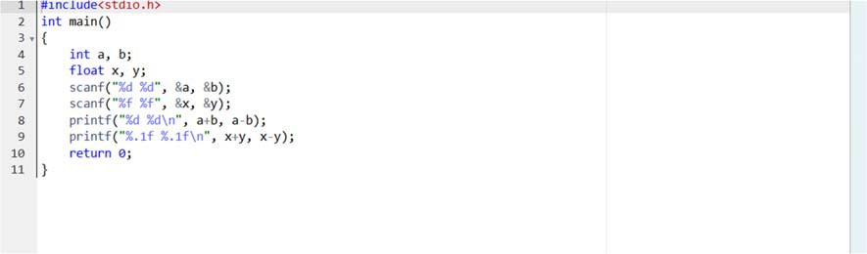

OUTPUT:

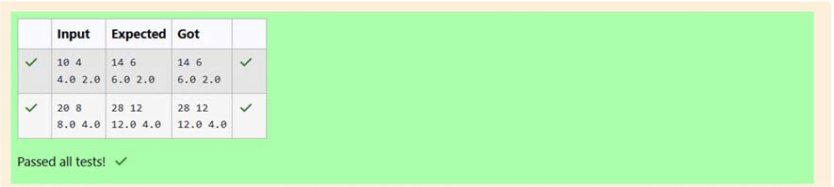

Week 1 – 02:

--Practice session – Coding. ROLL NO.:241801324
Name: Yogadharshini N K

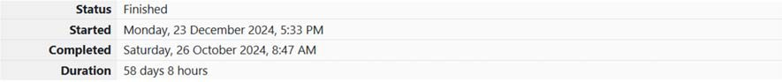
Q1) Write a program to input a name (as a single character) and marks of three tests as m1, m2, and m3 of a student considering all the three marks have been given in integer format. Now, you need to calculate the average of the given marks and print it along with the name as mentioned in the output format section. All the test marks are in integers and hence calculate the average in integer as well. That is, you need to print the integer part of the average only and neglect the decimal part. Input Format : Line 1 : Name(Single character) Line 2 : Marks scored in the 3 tests separated by single space. Output Format: First line of output prints the name of the student. Second line of the output prints the average mark. Constraints Marks for each student lie in the range 0 to 100 (both inclusive) Sample Input 1 : A 3 4 6 Sample Output 1 : A 4 Answer: (penalty regime: 0%)

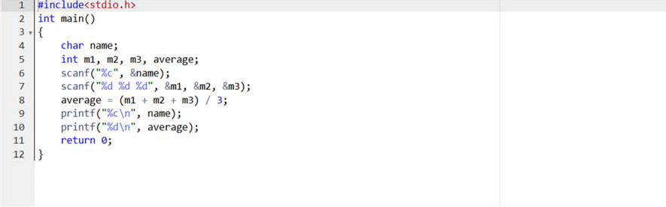

OUTPUT:

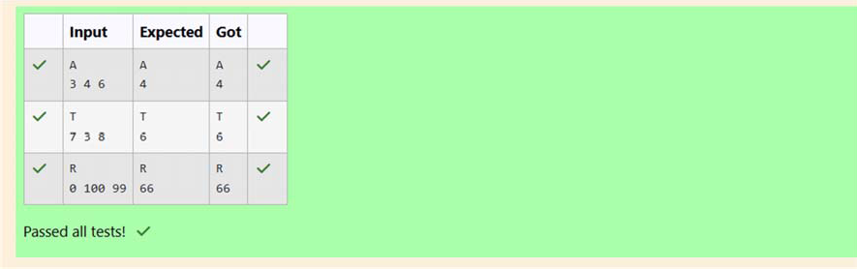

Q2) ) Some C data types, their format speciﬁers, and their most common bit widths are as follows: • Int ("%d"): 32 Bit integer • Long ("%ld"): 64 bit integer • Char ("%c"): Character type • Float ("%f"): 32 bit real value • Double ("%lf"): 64 bit real value Reading To read a data type, use the following syntax: scanf("`format_speciﬁer`", &val) For example, to read a character followed by a double: char ch; double d; scanf("%c %lf", &ch, &d); For the moment, we can ignore the spacing between format speciﬁers. Printing To print a data type, use the following syntax: printf("`format_speciﬁer`", val) For example, to print a character followed by a double: char ch = 'd'; double d = 234.432; printf("%c %lf”,&ch, d); Note: You can also use cin and cout instead of scanf and printf; however, if you are taking a million numbers as input and printing a million lines, it is faster to use scanf and printf. Input Format Input consists of the following space-separated values: int, long, char, ﬂoat, and double, respectively. Output Format Print each element on a new line in the same order it was received as input. Note that the ﬂoating-point value should be correct up to 3 decimal places and the double to 9 decimal places. Sample Input 3 12345678912345 a 334.23 14049.30493
Sample Output 3 12345678912345 a 334.230 14049.304930000

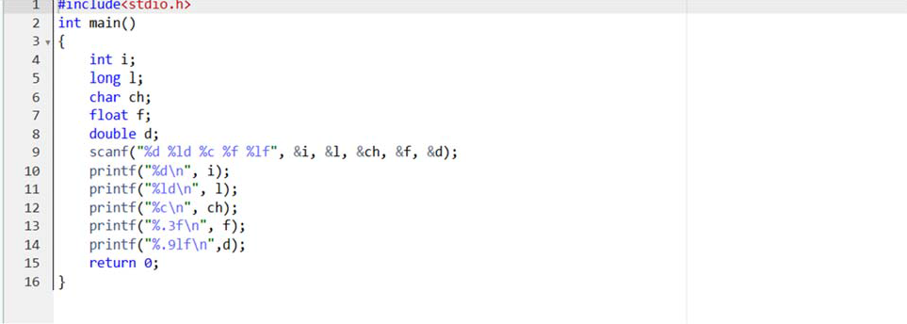

OUTPUT:

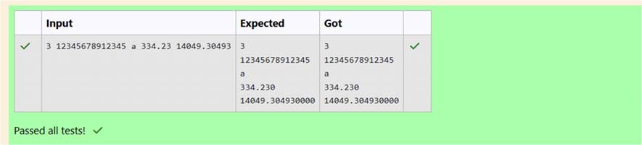
Q3) Write a program to print the ASCII value and the two adjacent characters of the given character. Input Format: Reads the character Output Format: First line prints the ascii value, second line prints the previous character and next character of the input character Sample Input 1: E Sample Output 1: 69 D

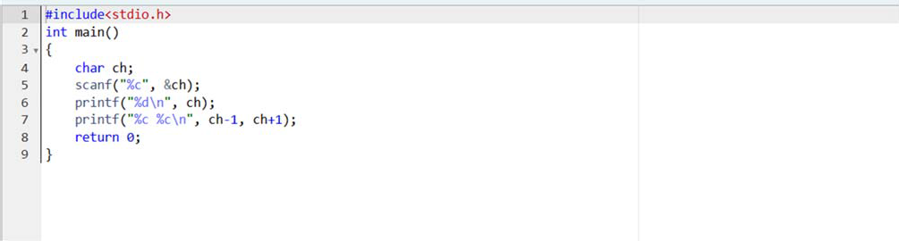
OUTPUT:

